

NANYANG BUSINESS SCHOOL

BC2407 Analytics II: Advanced Predictive Techniques
Project Report
LoS predictive models: Analytics solutions to Optimize Singapore’s Healthcare Capacity

Submitted by:
S02 - Group 7

Group Members
Trieu Phuong Anh U2210720K
Isabelle Lim Xin Yin U2310318C
Koh Zhi Liang U2310769E
Neo Yu Hui U2321332E
Raashi Singh U2323855J

Table of Contents
1. Executive Summary 3
1.1 Overview 3
1.2 Key Findings 3
1.3 Proposed Action Plans 3
2. Introduction 4
2.1 Background on Hospital Overcrowding 4
2.2 Project aim 4
2.3 Case Justification 4
3. Situational Analysis 5
4. Methods of Data Analysis 6
4.1 Dataset Sourcing 6
4.2 Data Preparation & Cleaning 6
4.3 Exploratory Data Analysis 7
4.4 Model Building 12
4.5 Model Evaluation & Selection 16
5. Key Findings from Selected Model 18
6. Recommendation 19
7. Overall Limitation and Future Work 21
7.1 Complexity of Discharge and Length of Stay 21
7.2 Limited Dataset 21
7.3 Future Work 21
8. Conclusion 21
9. Reference 22
10. Appendix 24
Appendix A: Data summary 24
Appendix B: Supplementary Data Visualization 28
Appendix C: Variable Grouping for Model building 29
Appendix D: Variable Importance 30
Appendix E: Model Code and Output 31

1. Executive Summary

1.1 Overview
This report explores how predictive models can help the Ministry of Health (MOH) in Singapore cope with the problem of hospital overcrowding. This issue has only gotten worse in the recent few years. The delay in the expansion of health care facilities together with the increase in the aging population, have caused increased pressure on hospital resources. The length of stay (LoS) in the hospital increased by 15% from 2019 to 2022 and the LoS increased from 6.1 to 7 days on average. Older people, especially those who are 65 years and above constitute 43% of hospital admissions in 2022 whereas in 2019 it was 39% (Khalik, 2024). Hence as hospitals are usually operating at full capacity, patients face longer waiting times of up to 20 hours or even more (Lee, 2024). This project aims to explore how predictive models can help in effective management of beds and patient flow to tackle overcrowding and increase the effectiveness of the health care system.

1.2 Key Findings
Through our detailed exploratory data analysis and models building, our group identified several factors that are key drivers of prolonged stays (defined as higher than a median stay length ~ over 5 days). Those include ICU stay status, type of admission, presence of non-comorbidity diseases, age, and abnormal medical index. It is also noteworthy that there is a seasonal pattern in hospital admission and readmission rate that can be utilized for proactive resource planning.
We evaluated four predictive models: Multivariate Adaptive Regression Splines (MARS), Random Forest, XGBoost, and Neural Network. Among them, Random Forest demonstrated the highest predictive accuracy, aligning well with established practices in healthcare analytics.

1.3 Proposed Action Plans
To cope with the identified issue, we propose 4 key recommendations including the application of predictive models of LoS into the hospital information system to receive real-time alert on the patients at high risk of prolonged stay, enabling early risk stratification at point of admission. We also recommend a proactive approach through dynamic resource planning that takes into consideration factors like seasonality to reduce bed bottleneck and improve patient flow. In the long run, it is also advisable for the MOH to devise targeting care protocols for high-risk patient groups with ICU need, non-cardiac comorbidity and elevated lab results - key drivers of long stays. Altogether, the integration of analytics models with promising performance like Random Forest and a dynamic dashboard, can support the MOH’s goals of building an agile and resilient healthcare system.

2. Introduction

2.1 Background on Hospital Overcrowding
Hospitals in Singapore are facing significant bed shortage due to a multitude of reasons such as the delay in opening new hospital facilities and older patients being hospitalized for longer due to more complex illnesses, has led to a bed crunch at the majority of the public hospitals in Singapore. Some hospitals such as Khoo Teck Puat Hospital (KTPH) facing a 100 percent occupancy on most days, as well as some like National University Hospital (NUH) letting patients know that they may have to wait for a bed for as long as 60 hours, has left Singapore in a critical shortage of hospital beds.

2.2 Project aim
We aim to provide the Ministry of Health (MOH) in Singapore accurate predictions of whether patients are at risk of prolonged hospital stay, using advanced predictive models, specifically for the cardiological unit. These insights would help hospitals improve bed allocation and patient flow, leading to faster bed turnover, as well as improved coordination between departments. Moreover, understanding a patient’s expected duration of stay also helps better optimize resource allocation, ensuring that essential medical equipment and supplies are adequately stocked. Given Singapore’s aging population, timely discharge predictions can help assist elderly homes and family caregivers in preparing for post-hospital care. This would aid external care providers in planning their resources effectively. Additionally, knowing in advance when beds will become available also allows departments to plan patient allocation more efficiently, enhancing overall healthcare efficiency.
Through data analysis and predictive modelling, our team aims to identify the critical factors influencing prolonged hospital stays. By recognizing these factors in incoming patients, hospitals can anticipate high-risk cases earlier and make informed clinical decisions for them in the early stages of their treatment, to help reduce their LoS.
By accurately classifying a patient’s LoS, we seek to enhance hospital preparedness and optimize allocation of scarce resources. This would enable hospitals to prioritize patients who are at high-risk, improving operational efficiency and ultimately refining patient experience.

2.3 Case Justification
Our team selected this case due to its potential to significantly impact the healthcare sector. To control costs while ensuring the highest quality of patient care, hospitals must allocate their resources efficiently. The primary goal of this project is to help hospitals maximize the use of their resources, thereby minimizing excessive expenses and enhancing overall operational performance.
This case is particularly important as it benefits both hospitals and patients. Hospitals can operate more efficiently, while patients experience improved care through the reduced waiting times and enhanced services. The practical benefits of this project make it highly relevant and impactful in tackling real-world healthcare challenges.
We have conducted extensive research on the feasibility of predictive models for estimating the length of hospital stays. Our key findings indicate that predictive modeling plays a significant role in enhancing hospital resource allocation, reducing patient wait times, and improving overall hospital efficiency.
- Machine Learning (ML) in Healthcare: ML algorithms are applied in healthcare for diagnosis, personalized medicine, treatment personalization, and outbreak prediction.
- LoS Prediction: Classification algorithms (decision trees, random forest, logistic regression) predict hospital admission, while regression algorithms (logistic regression, ElasticNet regression, support vector regression) forecast the number of days a patient will be hospitalized.
- Key Factors Influencing LoS: Patient demographics (age, gender), clinical features (diagnosis, severity of illness), and operational factors (admission type) are important.
- Commonly Used Algorithms: Regression models, neural networks, decision trees, ensemble methods (XGBoost) and other advanced models are used.
In conclusion, based on our situational research and insights from scientific studies and literature, we are confident in the relevance and feasibility of our project. By leveraging our chosen machine learning models, we aim to develop accurate predictions for hospital LoS classification, ultimately helping to mitigate hospital overcrowding.

3. Situational Analysis
Hospital overcrowding and high readmission rates are ongoing issues that result in long wait times, increased costs, and decreased patient satisfaction. In Singapore, the strain on public hospital resources has been exacerbated by delays in the opening of new facilities and an evolving patient demographic, which have become critical concerns. From 2019 to 2022, the average length of hospital stays increased by 15%, rising from 6.1 to 7 days, largely due to the aging population and the growing complexity of medical conditions. As a result, hospital bed occupancy rates have increased, with hospitals like KTPH operating at full capacity on most days. MOH has acknowledged that these challenges are not only driven by a backlog in hospital infrastructure but also by the after-effects of the COVID-19 pandemic, which may have contributed to a surge in hospital admissions and extended recovery times.
Based on our secondary research, news articles highlight the following key issues that led us to choose to tackle the problem statement of hospital overcrowding in Singapore:
- Long waiting times: Patients are experiencing significant delays in securing hospital beds, with median waiting times for emergency admissions around 7.5 hours. Some individuals have waited upwards of 38-46 hours, highlighting the severity of the problem.
- Aging population: As the population ages, hospitalizations are becoming more frequent and prolonged. Older patients often require longer stays due to complex medical needs, exacerbating the bed shortage.
- Pandemic aftermath: The COVID-19 pandemic has left a lasting impact, with deferred elective surgeries now requiring treatment and increased social isolation among seniors leading to longer inpatient stays.
- Discharge challenges: Even when patients are medically fit for discharge, various circumstances can lead to prolonged stays. These include a lack of family support, patient preference for remaining in the hospital, and delays in finalizing discharge plans.
- Resource optimization: Gender-based segregation in heavily subsidized wards can lead to sub-optimal resource allocation. The need to accommodate extra trolley beds within cubicles also places additional strain on healthcare workers.
Furthermore, Singapore has primarily relied on reactive and preventive strategies rather than proactive measures to overcome hospital overcrowding. MIC@Home program in Singapore is an example of a reactive approach which aims to bring in-patient level care to home instead of hospital wards to save up hospital beds. While this effectively alleviates immediate bed shortages and enhances patient satisfaction, it remains a reactive measure, addressing current capacity issues without forecasting future patient admission trends. Integrating proactive measures such as predictive models could enable healthcare institutions to anticipate patient influxes, optimize resource allocation, and implement preventive strategies to mitigate overcrowding before it occurs.

4. Methods of Data Analysis

4.1 Dataset Sourcing
We selected a publicly available dataset from Kaggle for our study. This dataset consists of patient records collected over a two-year period (April 1, 2017, to March 31, 2019) from Hero DMC Heart Institute, a unit of Dayanand Medical College and Hospital in India. As a tertiary care medical college and hospital, the cardiology unit admitted a total of 14,845 cases, corresponding to 12,238 unique patients. Among them, 1,921 patients had multiple hospital admissions.
Our team selected this dataset for its comprehensiveness and diversity, which we believe will yield valuable insights for our models and facilitate their application to the Singapore healthcare context. Given that India also faces significant hospital overcrowding challenges, this dataset serves as a relevant sample to demonstrate the effectiveness and adaptability of our models. By leveraging these findings, we aim to refine our approach and tailor the models to address Singapore’s specific healthcare needs.

4.2 Data Preparation & Cleaning
To enhance the quality and usability of our dataset for analysis, we performed several data cleaning steps to remove incomplete or irrelevant data.

 | Steps taken | Reason
1 | Renaming variables | Some variable names contained special characters or spacing, which could cause issues during data processing. These were replaced with “_” for consistency and readability.
2 | Drop unknown patient | A row had a patient with MRD number “NILL” which chose to remove, as it was unclear whether this entry was due to a readmission.
3 | Duplicate entries | Multiple rows had the same MRD number (admission number). We have identified some of these to be patients with readmissions and removed those with identical D_O_A (date of admission) which we considered to be duplicate records.
4 | Conversion of values to NA | Some columns contained values with blank string data or “EMPTY”, which we have interpreted to be missing values. Additionally, the CHEST_INFECTION column contained a category “\\”, which we also classified as NA.
5 | Removal of NA (Dropping columns) | Variables like BNP had a high proportion of missing values. Filling them using imputation could distort the data and introduce bias since the number of missing values is quite substantial. As such, they should be removed.
6 | Imputation of NA | The remaining variables with low percentage of NA should not be dropped as they are valuable for data analysis and do not require significant imputation. Irrelevant variables like MRD number are also removed before imputation to prevent noise in imputation and are added back after.
Table 1: Summary of data cleaning methods

4.3 Exploratory Data Analysis
- General Findings of LoS and admissions
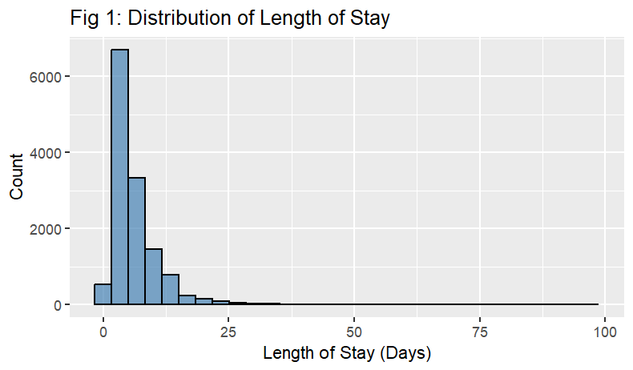
Figure 1: Distribution of Length of Stay
The histogram of the LoS (Fig 1) shows a right-skewed distribution, with the majority of patients having relatively short hospital stays, with an average of 6 days. However, there is a noticeable subset of patients who experience prolonged hospitalizations, indicating that while most cases are brief, some require extended care.
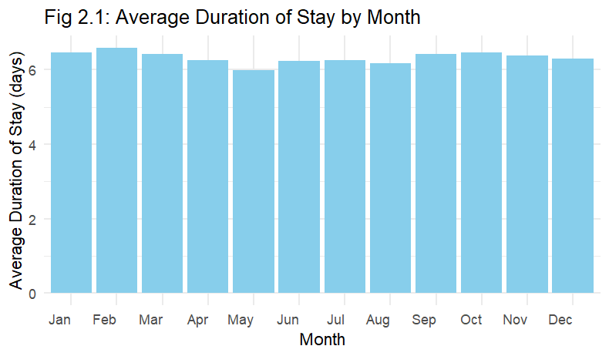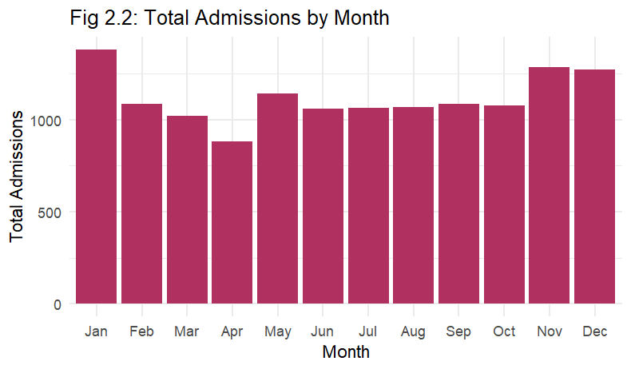
Figure 2.1 & 2.2: Duration and Admission by Month
The bar charts above (Fig 2.1 & Fig 2.2) illustrate the LoS and total admissions by month. Notably, admissions tend to be higher from November to January, while April records the lowest number of admissions, falling below 10,000. Although the average duration of stay remains relatively stable, there is a notable drop in LoS in May. These patterns offer insights into seasonal variations in hospital admissions and LoS, which can be leveraged to develop a predictive model that considers seasonal patterns (month_date) as key factors.
- Demographics Analysis
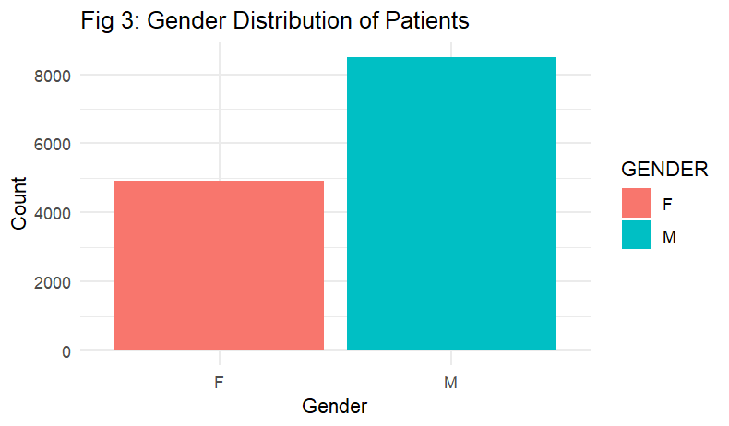
Figure 3: Gender Distribution of Patients
An analysis of patient demographics uncovers interesting details regarding the dataset. There is a significant gender imbalance (Fig 3), as the number of male patients (shown in teal) exceeds that of female patients (shown in red).
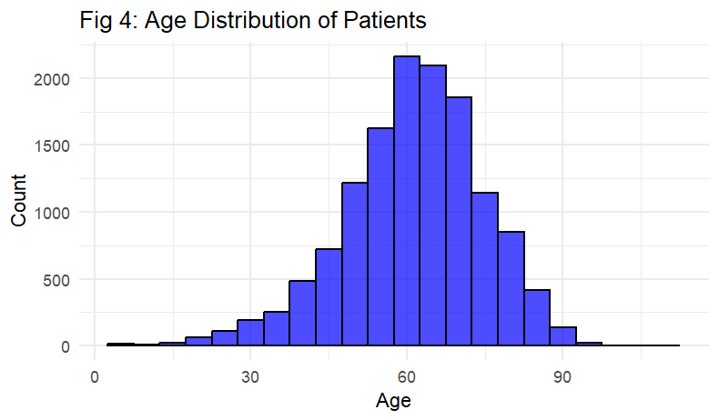
Figure 4: Age Distribution of Patients
The age distribution (Fig 4) exhibits a distinct peak in the 60s, indicating that this age group is more represented in the dataset and may suggest the presence of age-related health conditions.
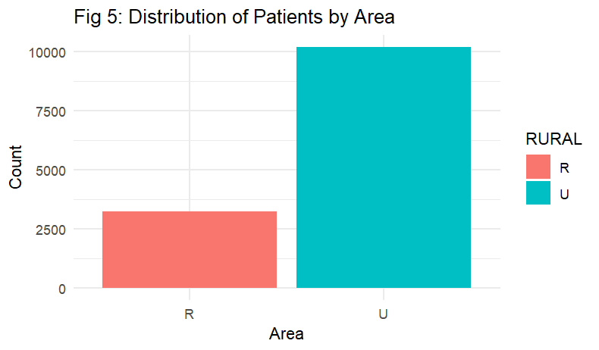
Figure 5: Distribution of Patients by Area
In addition, the examination of how patients are distributed geographically (Fig 5) reveals that the number of urban (U) patients surpasses that of rural (R) patients, indicating a focus on an urban-centric patient base.
- Patient’s Conditions Analysis
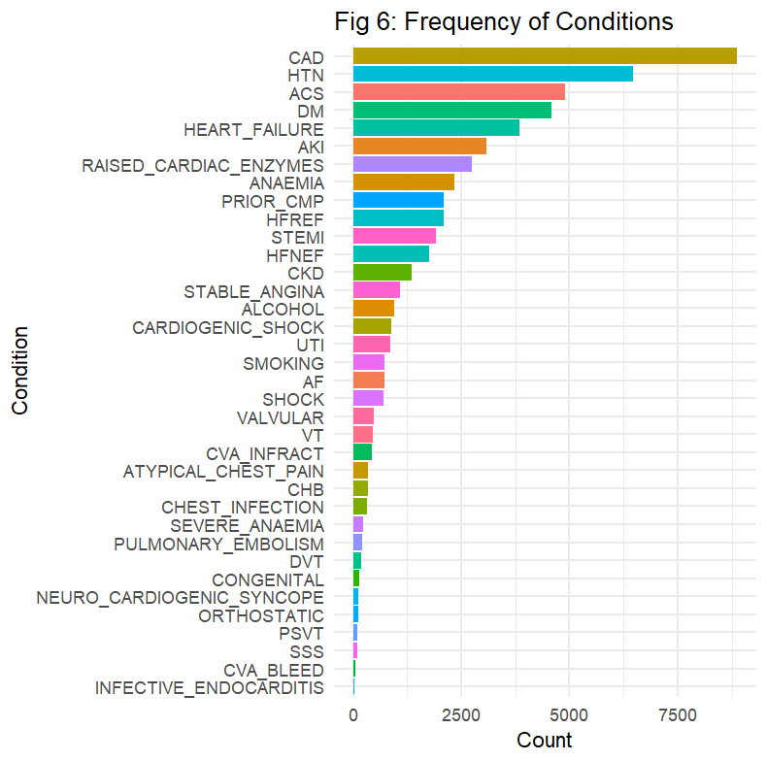
Figure 6: Frequency of Patient’s condition
We analyzed the frequency of grouped cardiovascular and comorbidity-related conditions among hospital admissions. Among the grouped categories, Chronic Cardiac Conditions such as Coronary Artery Disease (CAD) and Hypertension (HTN) appeared most frequently, with CAD alone accounting for over 10,000 cases. Acute Cardiac Events, including Acute Coronary Syndrome (ACS) and Heart Failure, also featured prominently with over 3,000 recorded cases each. Additionally, Diabetes Mellitus (DM), grouped under systemic comorbidities, was also highly prevalent. Conversely, less commonly observed conditions include Infective Endocarditis, Cerebrovascular Accident (CVA) bleeds, and Sick Sinus Syndrome (SSS), which fall under less frequent subgroups like OTHER_CARDIO and ARRHYTHMIA_CONDUCTION
Furthermore, we used Association Rule Mining to analyze hospital LoS by categorizing it into Below Average (1-4 days), Average (5 to 7 days), and Above Average (≥8 days). The association rules suggest that the presence or absence of specific medical conditions is strongly linked to an Above Average LoS in the hospital (greater than 7 days). Across the top rules, a common pattern emerges where the presence of Complete Heart Block (CHB), coupled with the absence of conditions such as STEMI, Anaemia, Cardiogenic Shock, ACS, and other cardiovascular complications, is associated with prolonged hospitalization. (see Appendix B-1)
The confidence values are relatively high, ranging from 68.6% to 70.5%, meaning that when these conditions occur together, there is approximately a 69–70% chance that the patient will have an Above Average LoS.
With the highest confidence rule (70.5%), it is suggested that patients with CHB but without Anaemia, STEMI, or Cardiogenic Shock are very likely to have an extended stay.
- Medical Index Analysis
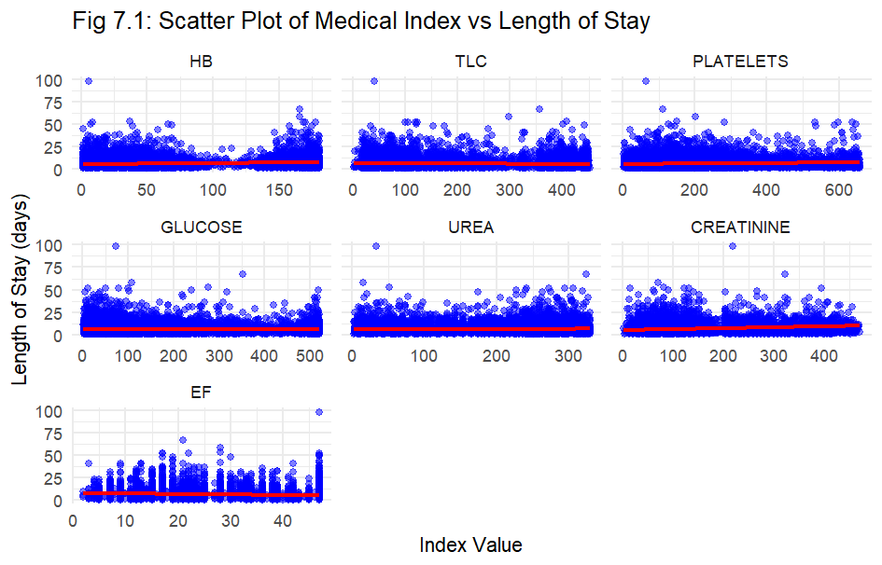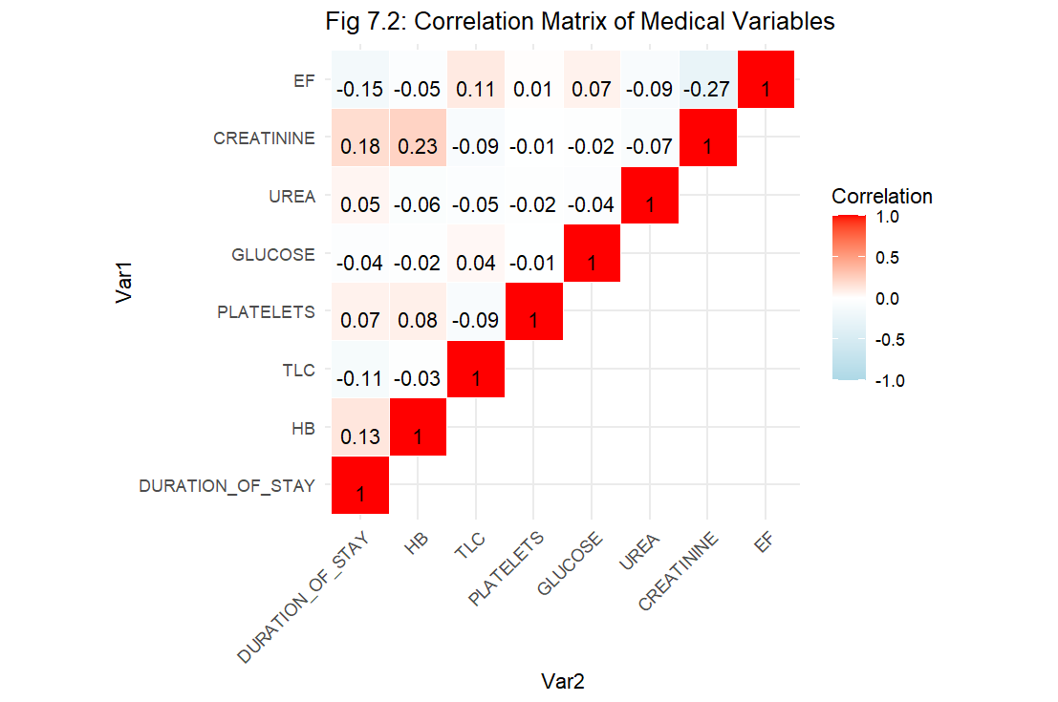
Fig 7.1 & 7.2: Scatter Plot and Correlation Matrix of Medical Index
We found that all the medical indexes in the dataset did not show strong linear relationships with LoS (Fig 7.1 & 7.2). However, we noted potential outliers in urea, and creatinine levels, which could represent critical cases that might be influencing longer hospital stays. These findings provide a foundation for further investigation into the factors affecting hospital stay duration.
- Mortality Rate Analysis
We used Association Rule Mining to analyze mortality rates by examining the relationships between different medical conditions and patient outcomes. From the association rule analysis we found that certain cardiovascular conditions are highly associated with an increased likelihood of mortality. (see Appendix B-2)
Moreover, we identified shared patterns indicating that the coexistence of Heart Failure with Reduced Ejection Fraction (HFREF), Cardiogenic Shock, Shock, and Acute Kidney Injury (AKI) is linked to a markedly elevated risk of death.
The confidence values are exceptionally high, ranging from 96.5% to 98.5%, meaning that when these conditions occur together, there is a 96–98% probability that the patient will not survive.
With the highest confidence rule (98.5%), it is suggested that patients with HFREF, Cardiogenic Shock, and Shock, combined with a short hospital stay, are almost certain to experience mortality. This highlights the urgency of early intervention for patients presenting with these critical conditions.
- Readmission Rate Analysis
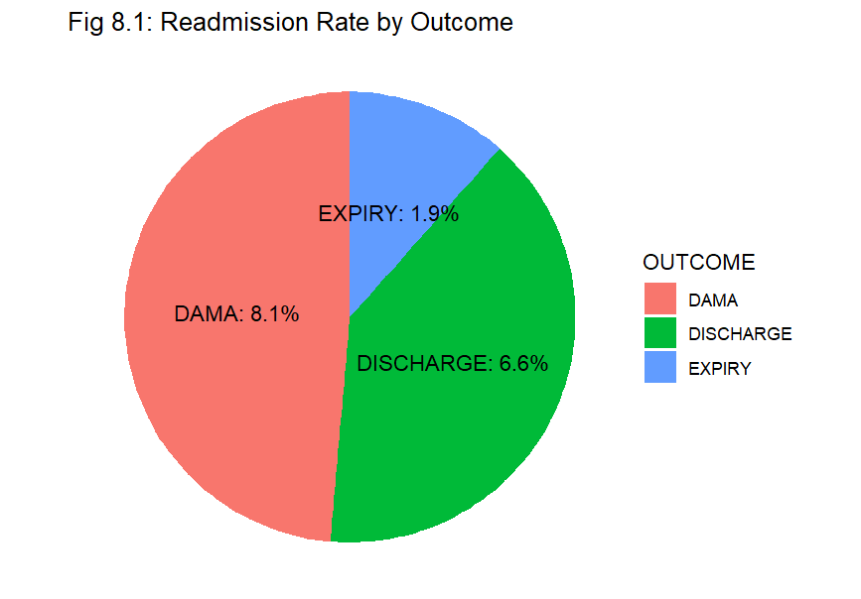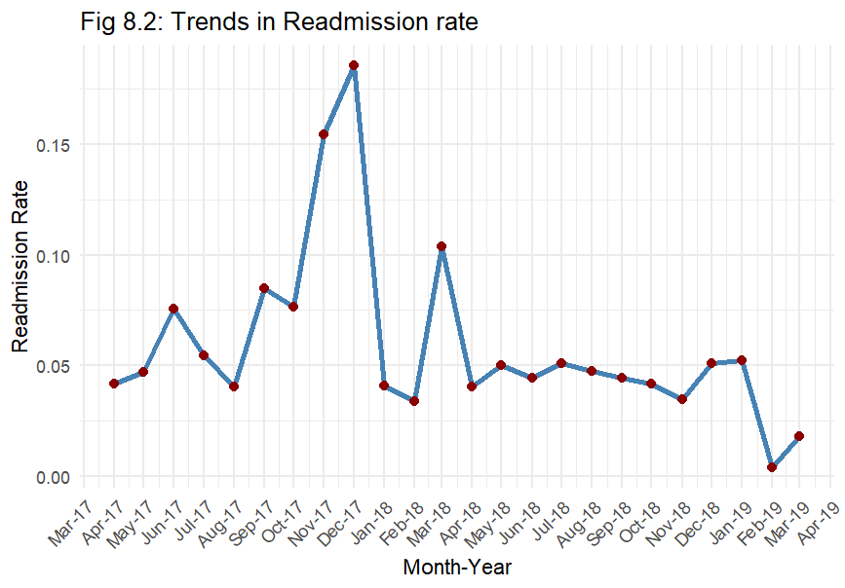
Fig 8.1 & 8.2: Outcomes and Trends of Readmission Rate
The pie chart shows DAMA (discharged against medical advice) patients group has the highest readmission rate (8.1%) (Fig 8.1). Patients who leave prematurely may not have completed treatment, leading to a greater chance of returning to the hospital shortly after.
The line chart highlights seasonal and operational fluctuations in readmissions. Spikes in late 2017 and early 2018 could reflect systemic pressures or inefficiencies, while the post-2018 period shows improved consistency. These patterns may inform planning for high-risk months and suggest where to strengthen discharge readiness and follow-up care.

4.4 Model Building
We split our dataset into train and test sets, so that we can successfully train our models, and test to gauge their accuracy by testing them against unseen testing data. Our team decided on a 70-30 ratio for our train-test dataset, respectively, with a set seed of 0, to ensure reproducibility. We made sure to use the same train test datasets for all our models, to ensure fairness.

4.4.1 Feature Selection
Choice of Target Variable: Classification task
Before building the predictive model, an important design decision was made to reframe the original problem of predicting the exact Length of Stay (LoS) into a classification task, categorizing patients into either "short" or "long" stay. This shift was motivated by practical and analytical considerations. Firstly, the dataset showed an imbalanced distribution, where long stays were relatively underrepresented, making regression models prone to biased predictions that favored the majority (short stays). Secondly, hospital LoS is influenced by a complex interplay of clinical, operational, and social factors, many of which are difficult to capture precisely or may not be available in the dataset. This introduces noise and unpredictability that can hinder regression accuracy. By converting LoS into a binary outcome using the median stay duration as a threshold, the model focuses on learning patterns that distinguish prolonged admissions from typical ones, allowing for more robust insights and actionable predictions that can better support hospital resource planning and early intervention strategies.

Grouping of factors
In the model-building phase, the dataset originally contained over 30 individual binary columns representing specific comorbidities and clinical conditions. While comprehensive, this level of granularity posed challenges for interpretability and model efficiency. To address this, related variables were logically grouped into broader clinical categories to extract more meaningful insights. For example, risk factors such as smoking, alcohol use were consolidated into a LIFESTYLE_RISK indicator, representing the presence of any lifestyle-related condition. Similarly, cardiovascular-related diagnoses were grouped into CHRONIC_CARDIO, ACUTE_CARDIO, ARRHYTHMIA_CONDUCTION, and OTHER_CARDIO, based on the nature and severity of the conditions (eg: coronary artery disease, heart failure, arrhythmias). Other non-cardiac comorbidities like diabetes, hypertension, and chronic kidney disease infections were combined under NON_CARDIAC_COMORBID. These new variables were derived by checking whether any of the associated conditions were present and assigning a "yes" or "no" accordingly. This grouping strategy not only reduced dimensionality but also enhanced interpretability, enabling the model to focus on broader health patterns rather than isolated diagnoses (see Appendix C).
Noise mitigation
As part of noise mitigation and dataset refinement, several preprocessing steps were taken to improve the quality and relevance of the data before model training. Patients with outcomes labeled as “DAMA” (Discharged Against Medical Advice) and “EXPIRY” (death) were excluded, as these atypical cases represent irregular discharge patterns that could introduce noise and bias into the model. Non-predictive columns such as patient identifiers (MRD_No_), admission timestamps (month_year), the actual outcome label, and the raw ICU stay duration were also removed to eliminate irrelevant information and prevent data leakage. To capture critical clinical features in a more interpretable way, a new binary variable was created to indicate whether a patient had an ICU stay, classified as "yes" if any time was spent in the ICU, and "no" otherwise. Additionally, all character-type variables were converted to factors for proper categorical handling. The continuous variable DURATION_OF_STAY was transformed into a binary classification target (Stay_Length) based on the dataset's median stay duration, allowing the model to differentiate between typical and prolonged admissions. These steps collectively simplified the dataset, reduced noise, and prepared the data for robust and interpretable classification modeling.

4.4.2 Models

MARS
MARS (Multivariate Adaptive Regression Splines) is a nonlinear regression technique which creates piecewise linear functions and is essentially used to capture complex interactions without the need of manual feature transformations.
Dealing with a dataset such as one with a real-life context of a hospital, it is paramount to consider that there might be interactions between one another. Each feature, in our opinion, has a strong possibility of not being independent of one another, and they might have some form of effect on other features. Hence, to confirm this, we wanted to compare the performance of our models using degree = 1, and degree = 2, in our MARS model. This can be seen under Appendix E-1/2/3. We found our model with degree = 2 to be marginally better, with a lower GCV (Generalised Cross Validation), lower RSS (Residual Sum of Squares) value, and a higher GRsq value. Hence, we made the decision to choose the model with degree = 2, due to its better predictive power.
Finally, to reduce the scope of over-fitting, we decided to do a 10-fold cross validation on our final model with our variables and with a degree = 2. With our final model fitted, we could predict on our test set. Using a confusion matrix, we displayed the results of our MARS model accuracy below, in Appendix E-4.

Neural Network
Neural networks are machine learning programs composed of multiple layers of interconnected nodes, each assigned specific weights. These connections enable the network to learn complex patterns more effectively than traditional machine learning models, making them particularly useful in analysing datasets with many features, such as those in healthcare.
Machine learning algorithms, such as neural networks, have various hyperparameters that need to be adjusted to achieve optimal model performance. To optimise our neural network model, our group experimented with multiple parameters, including hidden layer sizes and alpha values, to reduce overfitting and adjust the penalty applied to model weights.
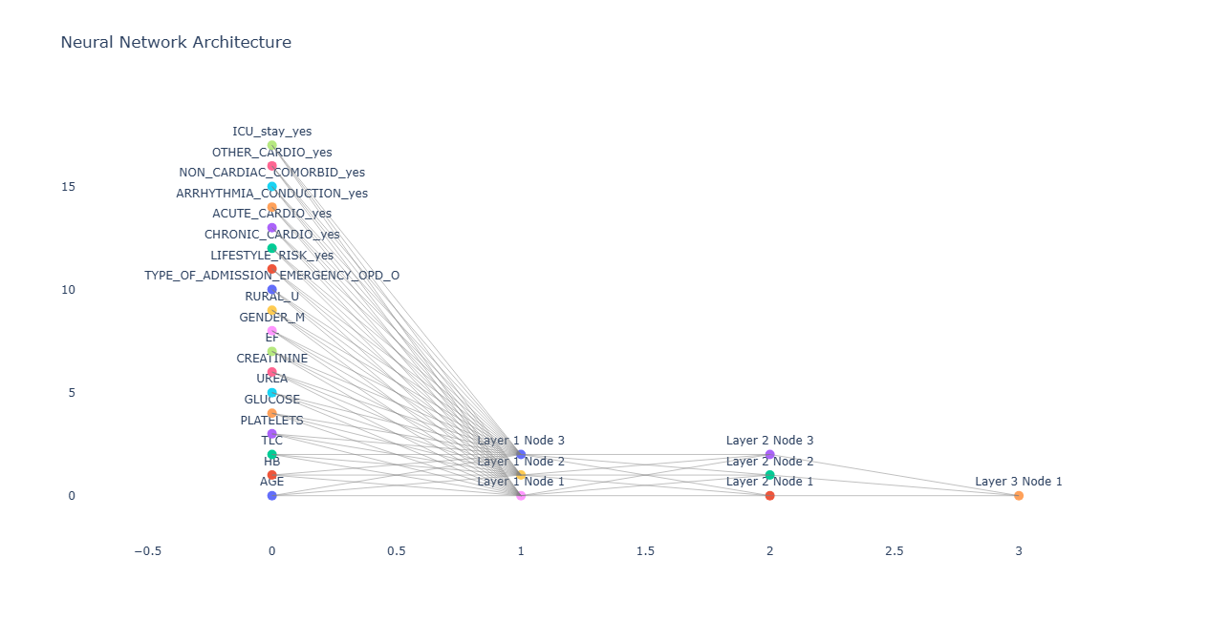
Figure 9: Visualisation of Neural Network Architecture
Through experimentation, we found that the optimal network dimension was (3,3), a relatively small structure. Increasing the number of nodes and layers significantly reduced the model’s performance, likely due to overfitting which thus resulted in difficulty generalising patterns in the dataset.
Additionally, we first trained the model with 1000 maximum iterations to analyse the loss curve (Appendix E-4), and identify where the loss plateaued. This indicated to us that additional training did not significantly improve model performance. Based on this, we selected a smaller iteration value of 100, which effectively prevented overfitting while also reducing computational time.
This approach to hyperparameter tuning ensured that our neural network model was optimised for both performance and efficiency.

Random Forest
Random Forest generates multiple decision trees each trained on a random subset of the data through the Bagging Method (Bootstrap Aggregation) and comes up with a final aggregated result. It is versatile, making it suitable for classification and regression tasks. Unlike decision trees which tend to suffer from overfitting, Random Forests Model is able to mitigate it by building many trees on bootstrapped samples and the use of random subset features at each split. However, as a tradeoff, Random Forest often requires more time and computational power to run and generate results.
There is two additional parameters to note when generating a Random Forest in RStudio:
ntree - This controls the number of trees generated. Generally, more trees lead to a better performance, but it will also cause longer computational time and higher computational cost. We used the typical value of 500 for our analysis.
mtry - This specifies the number of features to be considered at its split. The default value used is usually the square root of the total number of all predictors.
To identify the optimal mtry value for our model, we performed hyperparameter tuning with tuneRF function. This function evaluates model performances based on Out-of-Bag (OOB) errors at different mtry values and selects the value that minimises the error beyond a defined improvement threshold.
The following key parameters were used during the tuning process (For tuneRF function):
- ntreeTry: Number of trees trained during each evaluation
- stepFactor: Controls how much mtry increases during tuning (doubling at each step)
- improve: Specifies that a new mtry value must reduce OOB error by at least 1% (in this case the value used is 0.01) to be considered better
To determine the most suitable value for stepFactor, several trial-and-error tests were conducted by manually adjusting and monitoring the model performance. Values of 1.2, 1.5, 2 and 3 were tested. It was observed that smaller stepFactor values of 1.2 and 1.5 tend to result in suboptimal mtry values that often result in lower test accuracy. On the other hand, stepFactor value of 2 yielded the highest test accuracy and continued to remain stagnant as the value goes beyond 2. For ntreeTry and improve parameters, the value would be set to 500 and 0.01 respectively, following the standard practice. Therefore, with the parameters set, the best optimal mtry value came out to be 2.

XGBoost
Similar to Random Forest, XGBoost is a powerful ensemble learning model that builds decision trees. However, unlike Random Forest which constructs trees independently, XGBoost utilises gradient boosting, where multiple weak trees are trained sequentially, each correcting the errors of the previous ones. (IBM, 2024) The gradient descent algorithm in XGBoost helps minimise loss during training, making it highly effective for complex data like patient health records.
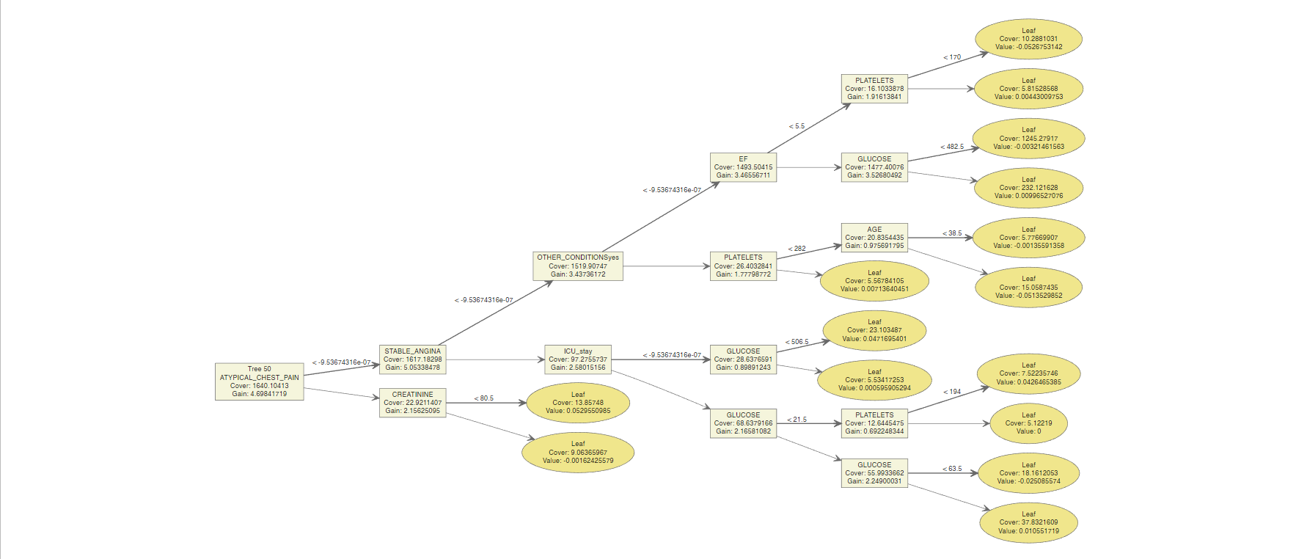
Figure 10: One of XGBoost’s Trees
Like our approach with neural networks and random forest, we tried various hyperparameters to optimise our XGBoost model, such as max depth and learning rate to balance between predictive performance and overfitting (Appendix E-5). Our final mode carefully selects values to reduce overfitting while maintaining predictive power. For instance, we set the iteration rounds to 100, as higher rounds led to overfitting and lower performance, while fewer rounds resulted in underfitting. Additionally, we set the max depth to 5 to prevent the model from becoming too complex and overfitting to training data, ensuring that it captures meaningful patterns in patient data without memorising noise.

4.5 Model Evaluation & Selection

4.5.1 Model Metrics
Model accuracy is crucial in the healthcare industry, as it enables hospitals to efficiently plan and allocate resources, allowing them to maximise the number of patients they can accommodate. To evaluate the accuracy and the robustness of our models, we utilised several performance metrics to give us a comprehensive understanding of their effectiveness.

Mean Accuracy
Accuracy measures the overall correctness of the model’s predictions. In the context of hospital LoS prediction, it tells us how often the model correctly classifies a patient’s stay as short or long. However, since hospital stays might be imbalanced (e.g., more short stays than long ones), accuracy alone may be misleading. A model predicting mostly short stays could still have high accuracy but fail to identify prolonged hospitalizations, which are critical for resource planning.

F1 Score
The F1 Score balances Precision (i.e., how many predicted long stays were truly long) and Recall (i.e., how many actual long stays were correctly identified). In hospitals, identifying long stays correctly is crucial because failing to do so could mean incorrectly allocated resources, as well as insufficient resources for high-risk patients. A good F1 score ensures the model can effectively predict prolonged hospitalizations while minimizing false alarms, which helps to better optimize bed management and staff allocation.

AUC (Area Under Curve)
AUC-ROC measures the model’s ability to distinguish between short and long stays. A higher AUC means the model is better at predicting which patients are likely to stay longer. This is particularly useful in hospitals for early intervention, allowing staff to prioritize high-risk patients, allocate resources efficiently, and reduce overcrowding.

4.5.2 Model Evaluation
Model | Mean Accuracy | F1 Score | AUC
MARS | 0.6939954 | 0.7035794 | 0.6946996
Random Forest | 0.6983000 | 0.7107667 | 0.7567520
Neural Network | 0.6890878 | 0.6812666 | 0.7491901
XGBoost | 0.6934180 | 0.6863556 | 0.7494948
Table 2: Summary of Model Performance
From Table 2, the models generally have similar performance, with Random Forest having the highest accuracy, F1 score and AUC.
Since hospital LoS is segmented into long and short stays based on the median, with short stays being the positive class, accuracy is a reasonable metric because the target variable is very highly balanced. In balanced datasets, accuracy provides a fair representation of overall model performance, as the model is not biased towards any majority class. By looking at this metric, Random Forest would be the ideal model to use for prediction.
Moreover, if hospitals prioritise efficient resource allocation, where it is crucial that patients do not exceed their estimated LoS, F1 score, and AUC become more important metrics as they assess how well the model can differentiate between long and short stays. Since Random Forest has the highest F1 score and AUC, it would still be the best model for minimising false positives, where a patient is predicted to have a short stay but ends up overstaying. Such misclassifications can lead to issues in bed availability, scheduling and resource planning.
Overall, Random Forest is the more reliable model for practical use, with its high scores across all 3 metrics, indicating that it can better predict both short and long stays accurately.
On the other hand, MARS, Neural Networks and XGBoost do not achieve similar performance as Random Forest. MARS may be less effective since it is not an ensemble-based model like Random Forest, and can be more prone to underfitting on training data.
Neural Networks may not perform as well since they generally require larger datasets to learn effectively and can overfit easily, unlike tree-based models. Additionally, multi-layer perceptron models like neural networks, tend to be less robust to noise (Grinsztajn et al., 2022), which is often present in healthcare datasets. This is because health outcomes are influenced by various external factors beyond a patient’s health statistics, making it challenging for neural networks to generalise well.
Similar to Neural Networks, XGBoost performs well on large and complex datasets. However, its boosting algorithm could lead to overfitting compared to Random Forest, which builds trees independently and is generally more robust to noise. Furthermore, some health statistics in our dataset may be weak predictors, and XGBoost’s iterative feature selection (XGBoosting, n.d.) could cause it to focus on these less relevant features, leading to poorer generalisation.

5. Key Findings from Selected Model
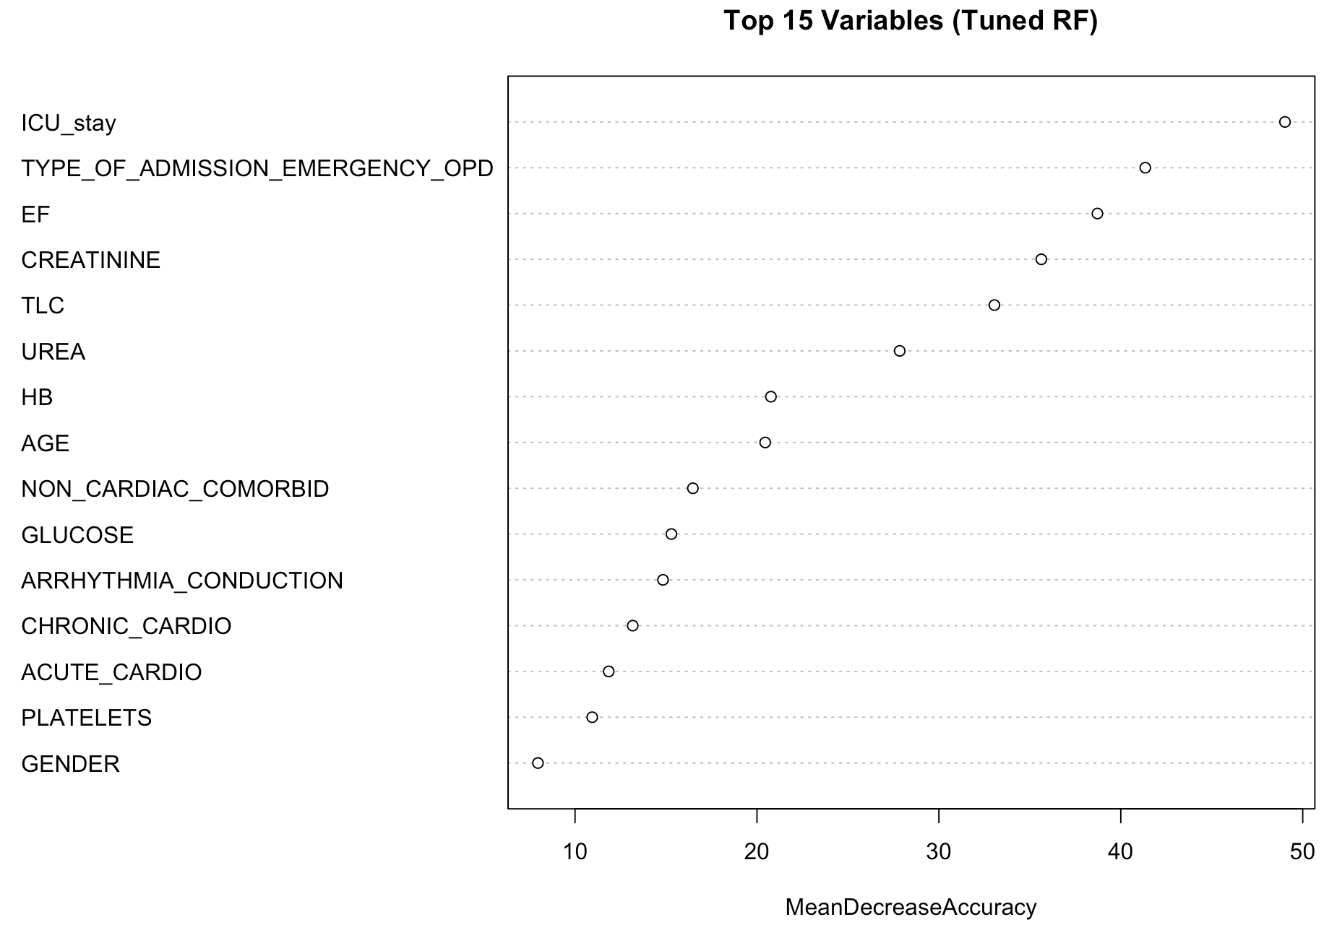
Figure 11: Variable Importance by Random Forest
At the top of the feature importance ranking is ICU_stay and Type of admission. Also among the most influential variables is Ejection Fraction, which signals cardiac function issue, as a strong driver of extended hospital stays. These findings are aligned with both the XGBoost and Neural Network models findings, where the same variables are also ranked among the top predictors (see Appendix D). It is indicated that patients who required intensive care through outpatient intake route are significantly more likely to experience prolonged hospitalization.
In addition, renal function indicators such as Creatinine and Urea, and inflammatory markers like TLC, ranked highly in the chart. These biomarkers often signify metabolic stress or organ dysfunction, which are drivers of prolonged stays (Brookes & Power, 2022), aligning with EDA observations of potential outliers in medical index values. The presence of these variables as top predictors suggests that biochemical deterioration is closely associated with increased LoS.
While grouped comorbidity variables such as non-cardiac comorbidity and arrhythmia conduction ranked slightly lower in the Random Forest model, they still contributed to predictive accuracy. This aligns with earlier descriptive analyses highlighting the frequency and relevance of these conditions, particularly systemic comorbidities like diabetes. Notably, secondary research indicates that non cardiac comorbidities like diabetes and hypertension as key contributors to extended LoS in heart failure patients, each associated with an increase of approximately 1.5 days in hospitalization (Tekle et al., 2022). Similarly, pre-existing arrhythmias are found to contribute to longer LoS, while postoperative arrhythmias are linked to a twofold increase in the likelihood of ICU stays exceeding 48 hours (Tunc et al., 2018).
Demographic variables such as Age and Gender had moderate importance. Age, particularly, aligns with the peak in admissions among older patients observed in the demographic analysis. Though these factors are less influential compared to clinical severity indicators, they remain relevant in refining risk stratification.
Overall, the Random Forest model not only confirms key patterns observed in EDA but also quantifies the relative importance of medical, procedural, and demographic variables in predicting prolonged hospital stays. Insights from MARS, XGBoost and Neural Network models further validate these findings, demonstrating consistency across algorithm types and reinforcing the reliability of the selected predictors (see Appendix D).

6. Recommendation
For MOH to improve hospital operations and enhance patient care outcomes, we recommend a holistic and system-wide 3-stage approach (Fig 12) that can be made based on insights from both the EDA and the predictive classification model:
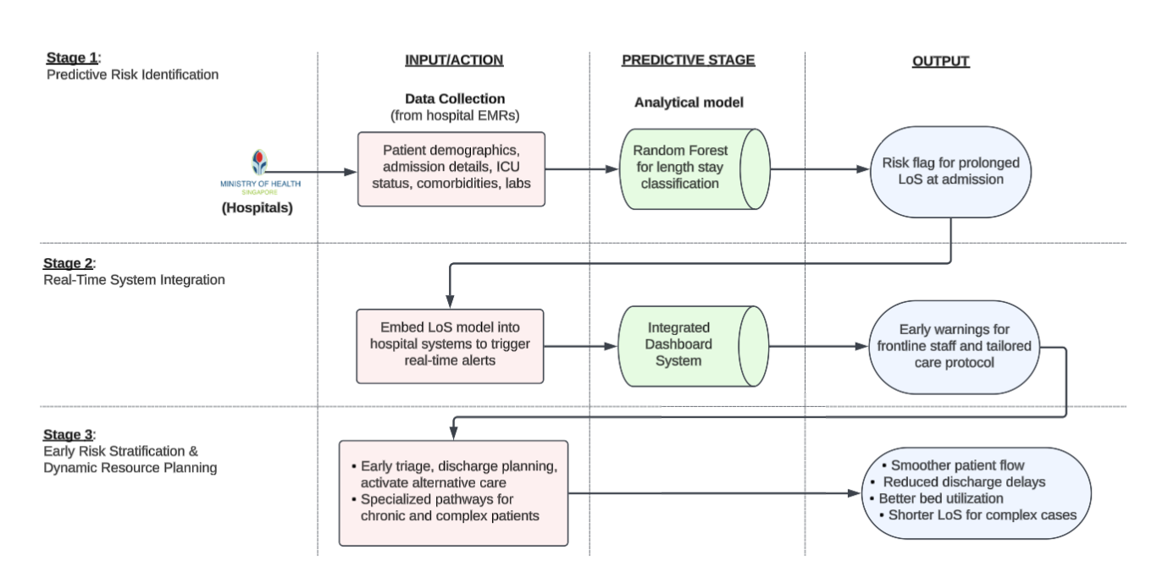
Figure 12: Solution Flowchart
This approach comprises three key stages, beginning with predictive risk identification at the point of admission. Hospitals, guided by MOH, should collect critical inputs such as patient demographics, ICU status, admission details, comorbidities, and lab results through their electronic medical records. These variables can be processed using machine learning models like Random Forest to classify patients at risk of prolonged LoS. The output is a real-time risk flag that enables more timely and informed decisions right from the start of the patient journey.
In the second stage, MOH can direct the integration of the predictive model into hospital computer systems to generate real-time alerts, ensuring their outputs are integrated within operational dashboards. These dashboards serve as critical touchpoints for clinical and administrative staff, triggering timely notifications and visual risk indicators. These alerts can be used to identify risk patients with prolonged lengths of stay shortly after admission, so frontline staff are better placed to make improved triage, bed assignment, and escalation of care decisions.
The third stage involves early risk stratification tools across hospitals. While existing tools like the LACE Index have primarily targeted readmission risk (Walji et al., 2021), applying similar analytics for LoS prediction is a new yet highly promising approach. This includes using flagged cases to guide more proactive triage decisions, initiate early discharge planning, and activate alternative care pathways such as step-down or home-based services. This not only avoids overcrowding but also facilitates more efficient hospital operation through more focused attention to closer cases. Systemic inefficiencies and areas of policy improvement can be determined over time through the use of aggregated model outputs. Moreover, hospitals should be encouraged to adopt dynamic resource planning based on observed seasonal trends. The analysis revealed monthly fluctuations in hospital admission, peaking in the months of January to March and October to December. With this pattern in mind, hospital administrators can use the seasonality flag within operational dashboards to better anticipate demand and deploy resources accordingly. Staffing rosters, bed allocations schedules can be adjusted to match anticipated load, hence reducing infrastructure strain during busy periods and avoiding underutilization in quieter months (Upshur et al., 2005). This ensures that appropriate levels of care are consistently maintained throughout the year.
Lastly, MOH is recommended to devise targeting care protocols for high-risk patient groups, particularly those with ICU needs through outpatient admission with severe lab results, non-cardiac comorbidities, and arrhythmia-related disorders. These clinical categories, as identified through both grouped feature importance and model analysis, were strongly associated with longer lengths of stay. Hospitals could develop or refine specialized care bundles and care pathways for these groups, involving frequent reviews and customized discharge planning (Shaw et al., 2020). Additionally, deploying care coordinators to manage transitions and communication across departments could further reduce unnecessary delays, improve continuity of care, and reduce readmission risks. These interventions can reduce avoidable delays, improve continuity of care, and decrease the likelihood of readmission. This aligns with national efforts to manage complex chronic conditions through the Healthier SG initiative.

7. Overall Limitation and Future Work

7.1 Complexity of Discharge and Length of Stay
Hospital LoS is influenced by more than just clinical conditions. Factors like caregiver readiness, availability of community care, administrative delays, and financial issues often play a role. These non-clinical elements are difficult to capture in structured datasets, making exact discharge prediction challenging. Given this complexity, this project framed the task as a binary classification problem (short vs long stay), rather than attempting to forecast the precise number of days. This approach is more practical and actionable in real-time hospital settings, where care teams can focus early attention on patients likely to exceed the average stay duration, providing useful support for discharge planning and resource allocation.

7.2 Limited Dataset
The second challenge lies in the nature of the dataset, while medically rich, contains noise, imbalance, and underrepresentation of long-stay cases. Many influential factors behind prolonged admissions are either missing or not directly measurable. To mitigate this, we cleaned the data (eg: removed DAMA and EXPIRY cases) and reframed the problem as a classification task using the median stay as a threshold. This helped ensure model robustness while still providing meaningful clinical insights.

7.3 Future Work
Looking ahead, the model should be routinely retrained every 6 to 12 months to stay aligned with evolving clinical practices and patient profiles. More advanced ensemble techniques like stacking or boosting can also be explored to enhance predictive performance (Singh, 2025). If more granular and longitudinal data becomes available, future models could revisit regression approaches to estimate exact LoS. This would enable more precise forecasting of bed usage and discharge timelines.

8. Conclusion
This project demonstrates the practical value of applying predictive analytics to support hospital operations, particularly in managing and anticipating prolonged inpatient stays. By leveraging clinical variables such as ICU stay and grouped comorbidities, especially non-cardiac conditions like chronic kidney disease. diabetes, and infections, the model offers a reliable method for early identification of patients at risk of extended hospitalization. The classification approach, using a binary outcome of short vs long stay, proved to be both interpretable and actionable, aligning well with the realities of hospital workflow and the complexity of discharge decisions.
From early risk stratification to real-time predictive alerts, the recommendations outlined are geared toward enabling proactive care planning, more efficient resource use, and improved patient flow. Moving forward, continuous model refinement and the inclusion of richer data sources can further enhance its impact, supporting the Ministry of Health’s goals of building an agile and resilient healthcare system.

9. Reference
Brookes, E. M., & Power, D. A. (2022). Elevated serum urea-to-creatinine ratio is associated with adverse inpatient clinical outcomes in non-end stage chronic kidney disease. Scientific Reports, 12(1). https://doi.org/10.1038/s41598-022-25254-7
Delivering care beyond hospitals. (2024, March 6). Ministry of Health. https://www.moh.gov.sg/newsroom/delivering-care-beyond-hospitals
Grinsztajn, L., Oyallon, E., & Varoquaux, G. (2022). Why do tree-based models still outperform deep learning on tabular data? arXiv (Cornell University). https://doi.org/10.48550/arxiv.2207.08815
IBM. (2024, December 19). XGBoost. IBM. https://www.ibm.com/think/topics/xgboost
MDPI. (2024, November 15). Hospital Length-of-Stay Prediction Using Machine Learning Algorithms—A Literature Review. https://www.mdpi.com/2076-3417/14/22/10523
Ministry of Health. (n.d.) Speech by Mr Ong Ye Kung, minister for health, at the ministry of health committee of supply debate 2024, on Wednesday 6 March 2024.https://www.moh.gov.sg/newsroom/speech-by-mr-ong-ye-kung-minister-for-health-at-the-ministry-of-health-committee-of-supply-debate-2024-on-wednesday-6-march-2024
National Library of Medicine. (2022, May 25). Forecasting hospital readmissions with machine learning. PMC Home. https://pmc.ncbi.nlm.nih.gov/articles/PMC9222500/
Salma Khalik and Lee Li Ying. (2023, April 22). Longer waiting times for beds in some hospitals, but treatment not delayed: MOH. The Straits Times. https://www.straitstimes.com/singapore/politics/longer-waiting-times-for-beds-in-some-hospitals-but-treatment-not-delayed-moh
Salma Khalik. (2023, May 4). Longer hospital stays for older patients a major reason for high bed occupancy: MOH. The Straits Times. https://www.straitstimes.com/singapore/longer-hospital-stays-for-older-patients-a-major-reason-for-high-bed-occupancy-moh
Shaw, A., Morton, K., King, A., Chalder, M., Calvert, J., Jenkins, S., & Purdy, S. (2020). Using and implementing care bundles for patients with acute admission for COPD: qualitative study of healthcare professionals’ experience in four hospitals in England. BMJ Open Respiratory Research, 7(1), e000515. https://doi.org/10.1136/bmjresp-2019-000515
Singh, A. (2025, January 3). A Comprehensive Guide to Ensemble Learning (with Python codes). Analytics Vidhya. https://www.analyticsvidhya.com/blog/2018/06/comprehensive-guide-for-ensemble-models/
Tekle, M. T., Bekalu, A. F., & Tefera, Y. G. (2022). Length of hospital stay and associated factors among heart failure patients admitted to the University Hospital in Northwest Ethiopia. PLoS ONE, 17(7), e0270809. https://doi.org/10.1371/journal.pone.0270809
Teo, J. (2023, September 27). Nationwide heart health study launched to help pick up hidden diseases. The Straits Times. https://www.straitstimes.com/singapore/health/launch-of-nationwide-preventive-heart-health-study-to-help-pick-up-hidden-diseases
Tunc, M., Sahutoglu, C., Karaca, N., Kocabas, S., & Askar, F. Z. (2018). Risk factors for prolonged intensive care unit stay after open heart surgery in adults. Türk Anestezi Ve Reanimasyon Dergisi, 46(4), 283–291. https://doi.org/10.5152/tjar.2018.92244
Upshur, R. E., Moineddin, R., Crighton, E., Kiefer, L., & Mamdani, M. (2005). Simplicity within complexity: Seasonality and predictability of hospital admissions in the province of Ontario 1988–2001, a population-based analysis. BMC Health Services Research, 5(1). https://doi.org/10.1186/1472-6963-5-13
Walji, S., McIsaac, W., Moineddin, R., Kalia, S., Levy, M., Tu, K., & Bell, C. M. (2021). Predicting hospital readmission risk: A prospective observational study to compare primary care providers’ assessments with the LACE readmission risk index. PLoS ONE, 16(12), e0260943. https://doi.org/10.1371/journal.pone.0260943
XGBoosting. (n.d.). Use XGBoost feature importance for incremental feature selection. https://xgboosting.com/use-xgboost-feature-importance-for-incremental-feature-selection/

10. Appendix

Appendix A: Data summary
Link to dataset: https://www.kaggle.com/datasets/ashishsahani/hospital-admissions-data
Source: Kaggle
The dataset “HDHI Admission data” consists of 56 columns, with a mix of numerical and categorical data.
Column Name | Explanatory Name
SNO | Serial Number
MRD No. | Admission Number
D.O.A | Date of Admission
D.O.D | Date of Discharge
AGE | AGE
GENDER | GENDER
RURAL | RURAL(R) /Urban(U)
TYPE OF ADMISSION-EMERGENCY/OPD | TYPE OF ADMISSION-EMERGENCY/OPD
month year | month year
DURATION OF STAY | DURATION OF STAY
duration of intensive unit stay | duration of intensive unit stay
OUTCOME | OUTCOME
SMOKING | SMOKING
ALCOHOL | ALCOHOL
DM | Diabetes Mellitus
HTN | Hypertension
CAD | Coronary Artery Disease
PRIOR CMP | CARDIOMYOPATHY
CKD | CHRONIC KIDNEY DISEASE
HB | Haemoglobin
TLC | TOTAL LEUKOCYTES COUNT
PLATELETS | PLATELETS
GLUCOSE | GLUCOSE
UREA | UREA
CREATININE | CREATININE
BNP | B-TYPE NATRIURETIC PEPTIDE
RAISED CARDIAC ENZYMES | RAISED CARDIAC ENZYMES
EF | Ejection Fraction
SEVERE ANAEMIA | SEVERE ANAEMIA
ANAEMIA | ANAEMIA
STABLE ANGINA | STABLE ANGINA
ACS | Acute coronary Syndrome
STEMI | ST ELEVATION MYOCARDIAL INFARCTION
ATYPICAL CHEST PAIN | ATYPICAL CHEST PAIN
HEART FAILURE | HEART FAILURE
HFREF | HEART FAILURE WITH REDUCED EJECTION FRACTION
HFNEF | HEART FAILURE WITH NORMAL EJECTION FRACTION
VALVULAR | Valvular Heart Disease
CHB | Complete Heart Block
SSS | Sick sinus syndrome
AKI | ACUTE KIDNEY INJURY
CVA INFRACT | Cerebrovascular Accident INFRACT
CVA BLEED | Cerebrovascular Accident BLEED
AF | Atrial Fibrilation
VT | Ventricular Tachycardia
PSVT | PAROXYSMAL SUPRA VENTRICULAR TACHYCARDIA
CONGENITAL | Congenital Heart Disease
UTI | Urinary tract infection
NEURO CARDIOGENIC SYNCOPE | NEURO CARDIOGENIC SYNCOPE
ORTHOSTATIC | ORTHOSTATIC
INFECTIVE ENDOCARDITIS | INFECTIVE ENDOCARDITIS
DVT | Deep venous thrombosis
CARDIOGENIC SHOCK | CARDIOGENIC SHOCK
SHOCK | SHOCK
PULMONARY EMBOLISM | PULMONARY EMBOLISM
CHEST INFECTION | CHEST INFECTION

Appendix B: Supplementary Data Visualization
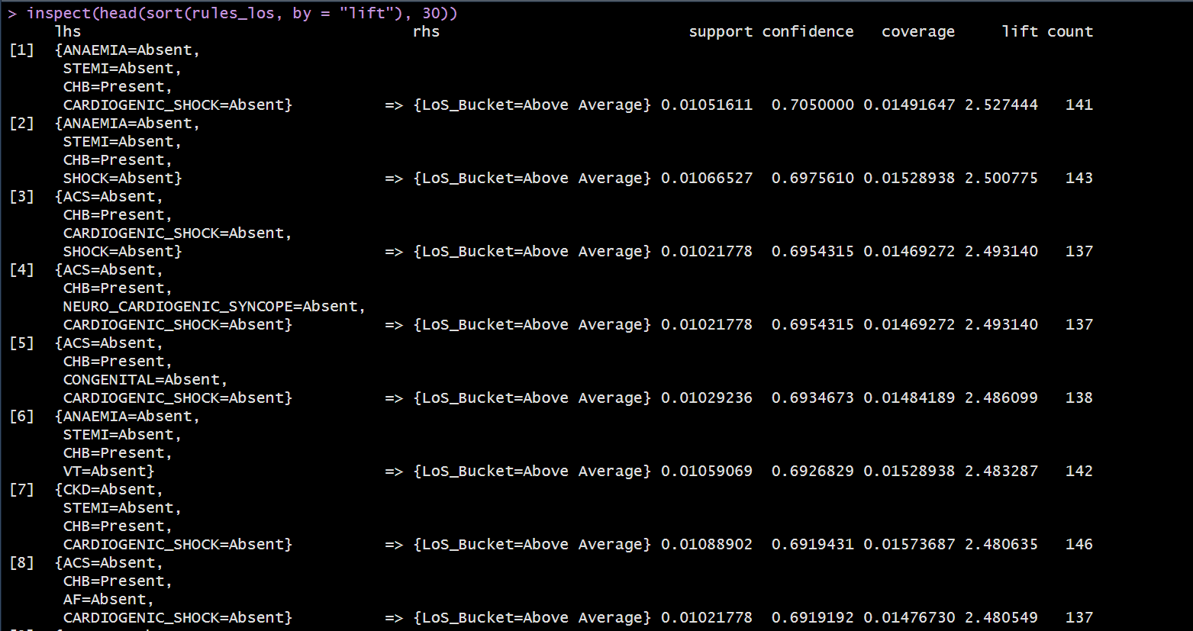
Appendix B-1: Association Rules - LoS bucket
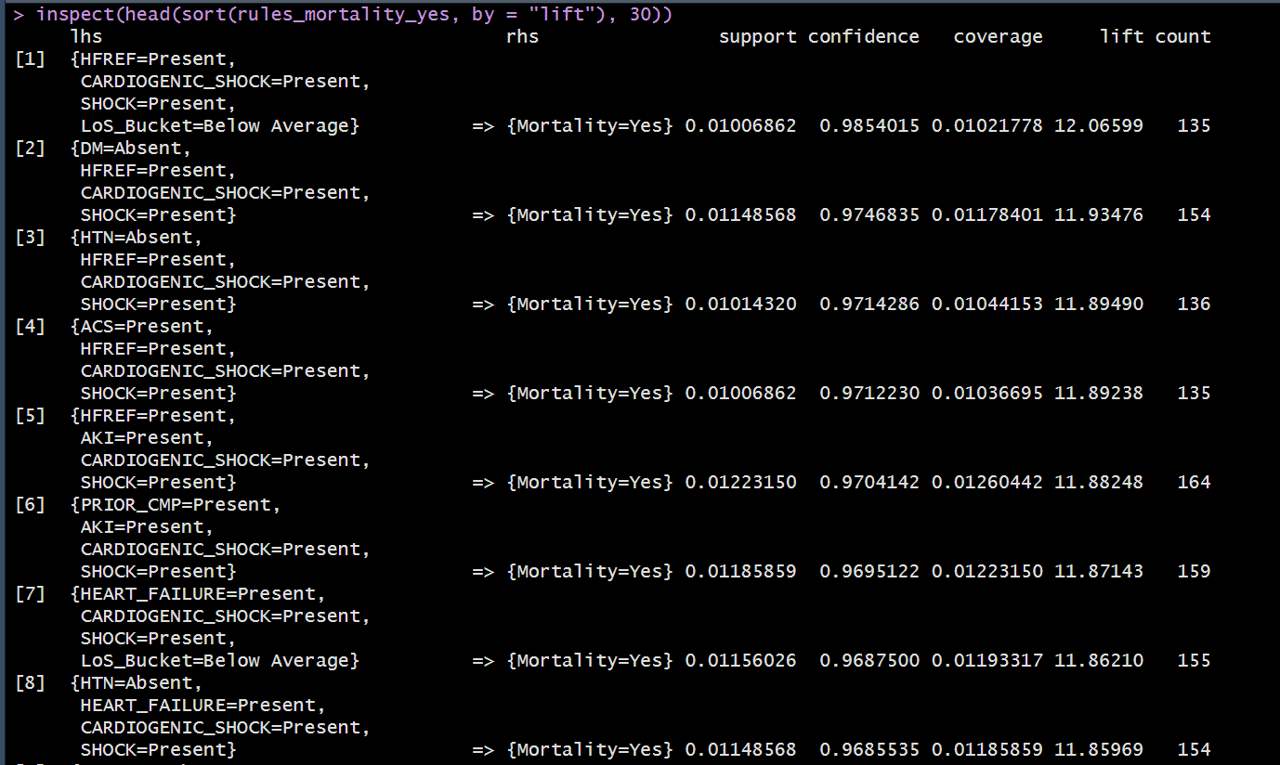
Appendix B-2: Association Rules - Mortality rate

Appendix C: Variable Grouping for Model building
Group name | Conditions included
LIFESTYLE_RISK | SMOKING, ALCOHOL
CHRONIC_CARDIO | CAD, STABLE_ANGINA, VALVULAR, HFREF, HFNEF, HEART_FAILURE, AF, CONGENITAL
ACUTE_CARDIO | ACS, STEMI, ATYPICAL_CHEST_PAIN, RAISED_CARDIAC_ENZYMES, CARDIOGENIC_SHOCK, SHOCK, PULMONARY_EMBOLISM
ARRHYTHMIA_CONDUCTION | CHB, SSS, VT, PSVT, NEURO_CARDIOGENIC_SYNCOPE, ORTHOSTATIC
NON_CARDIAC_COMORBID | CVA_INFRACT, CVA_BLEED, AKI, ANAEMIA, SEVERE_ANAEMIA, UTI, CHEST_INFECTION, CKD, DM
OTHER_CARDIO | PRIOR_CMP, INFECTIVE_ENDOCARDITIS, DVT, HTN

Appendix D: Variable Importance

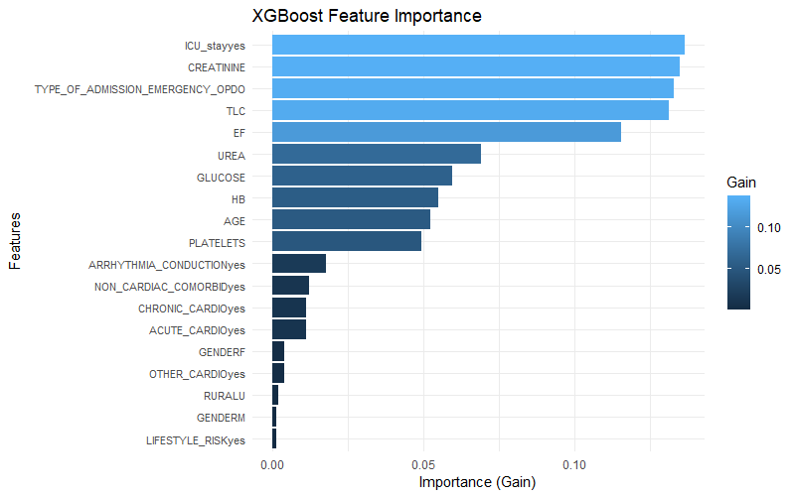
Appendix D-1
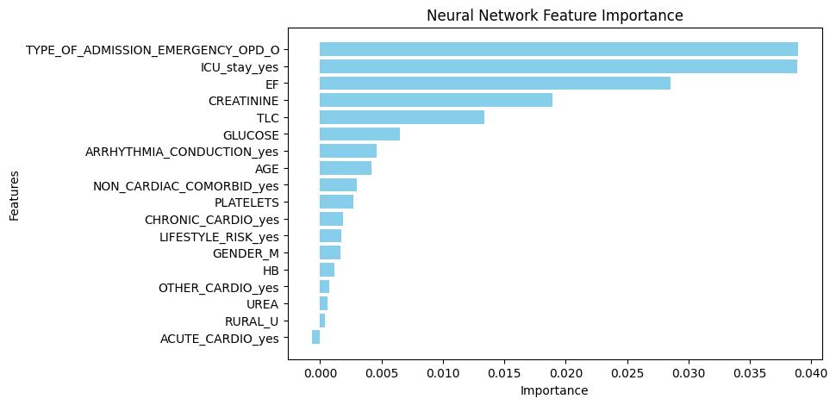
Appendix D-2

Appendix E: Model Code and Output
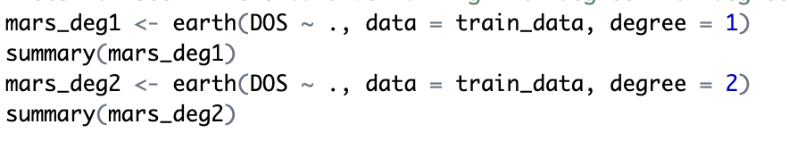
Appendix E-1
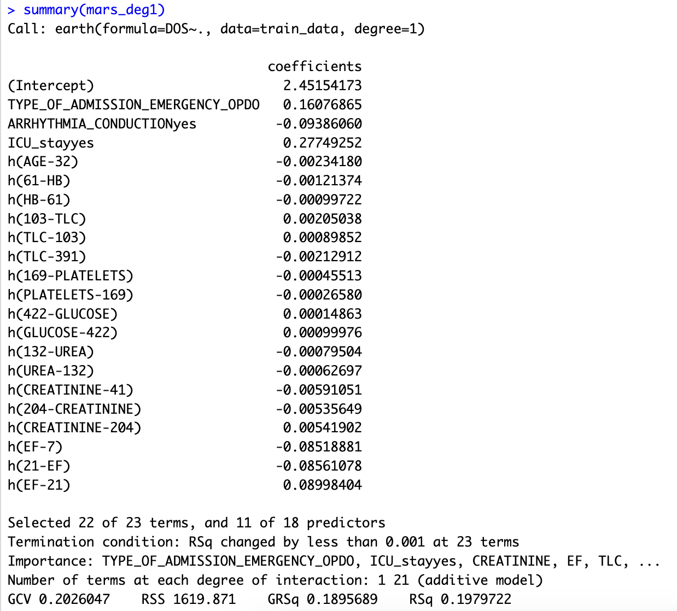
Appendix E-2
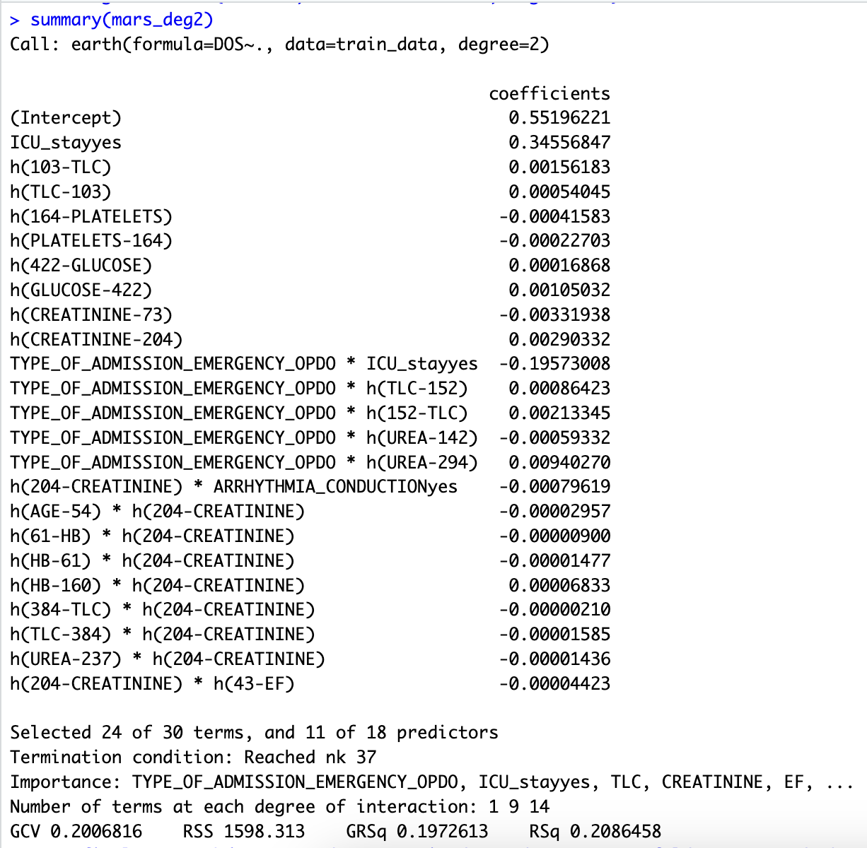
Appendix E-3

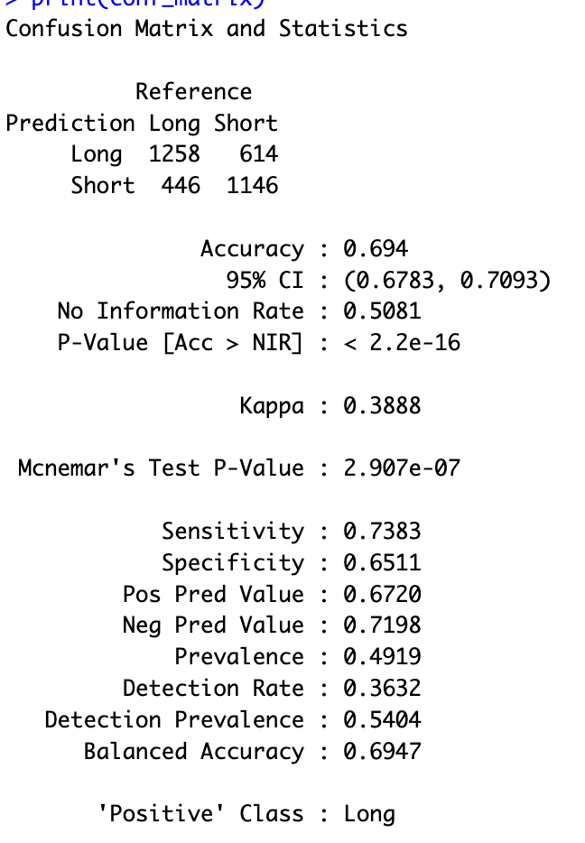
Appendix E-4
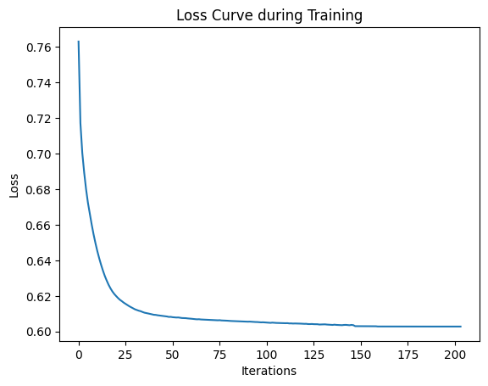
Appendix E-4
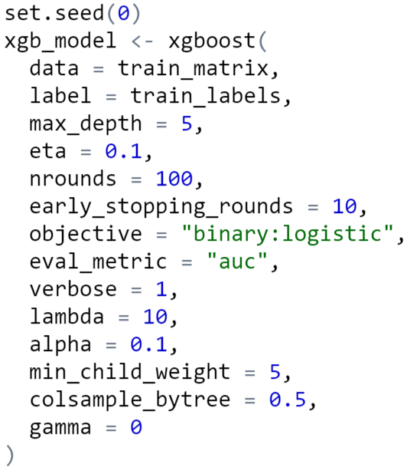
Appendix E-5

